Chapter 3, Solution 81

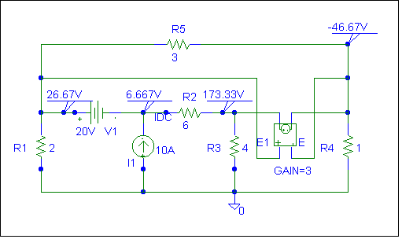
Clearly, v₁ = 26.67 volts, v₂ = 6.667 volts, v₃ = 173.33 volts, and v₄ = –46.67 volts
which agrees with the results of Example 3.4.

This is the netlist for this circuit.

* Schematics Netlist *

R_R1 0 $N_0001 2
R_R2 $N_0003 $N_0002 6
R_R3 0 $N_0002 4
R_R4 0 $N_0004 1
R_R5 $N_0001 $N_0004 3
I_I1 0 $N_0003 DC 10A
V_V1 $N_0001 $N_0003 20V
E_E1 $N_0002 $N_0004 $N_0001 $N_0004 3

